Test Case: tc005_SPX_Dev5_Crear_Requisicion_Spot_Con_FAD_Tipo_Cobro_Project
Step 1 - Enter username and password and click to button Enter: Credentials Entered
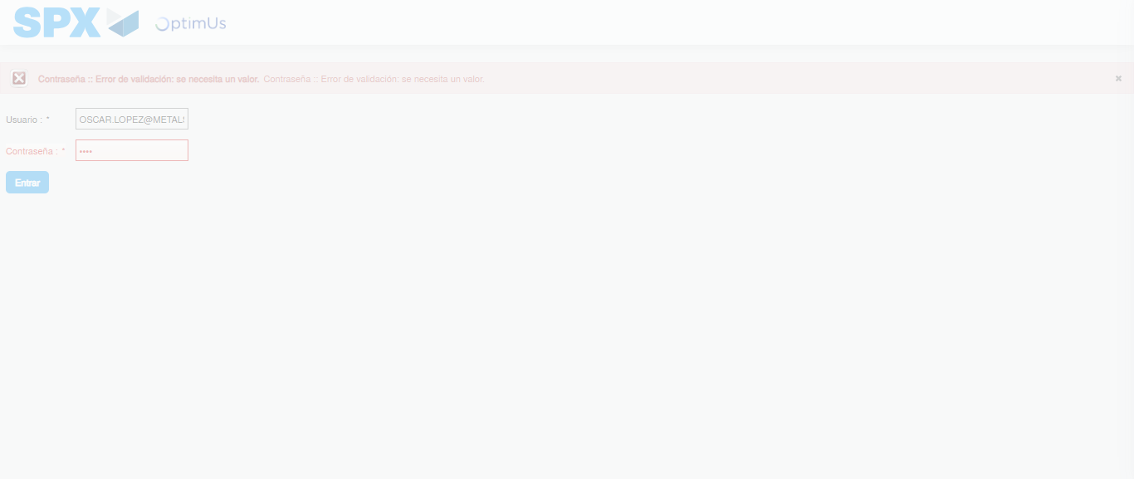Image file-name: QC_Testing-tc005_SPX_Dev5_Crear_Requisicion_Spot_Con_FAD_Tipo_Cobro_Project-1784653443092

Step 2 - Select to UEN and Access to Spot Buy Requisitions : UEN Correctly selected and Correct access
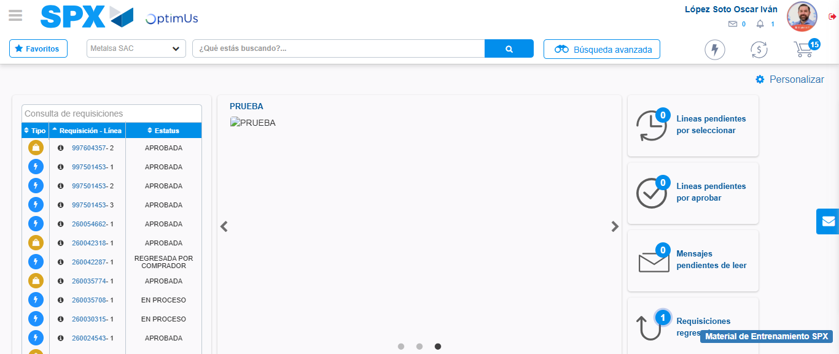Image file-name: QC_Testing-tc005_SPX_Dev5_Crear_Requisicion_Spot_Con_FAD_Tipo_Cobro_Project-1784653469050

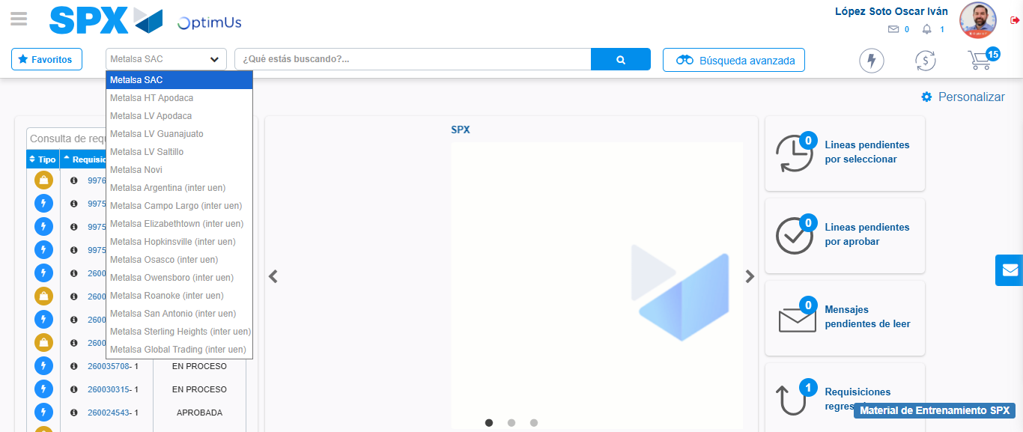Image file-name: QC_Testing-tc005_SPX_Dev5_Crear_Requisicion_Spot_Con_FAD_Tipo_Cobro_Project-1784653471849

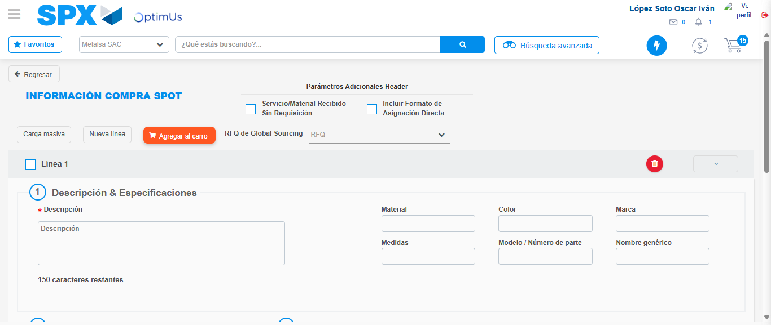Image file-name: QC_Testing-tc005_SPX_Dev5_Crear_Requisicion_Spot_Con_FAD_Tipo_Cobro_Project-1784653492113

Step 3 - Add FAD to Requisition: FAD Successfully Added
Image file-name: QC_Testing-tc005_SPX_Dev5_Crear_Requisicion_Spot_Con_FAD_Tipo_Cobro_Project-1784653492362

Image file-name: QC_Testing-tc005_SPX_Dev5_Crear_Requisicion_Spot_Con_FAD_Tipo_Cobro_Project-1784653492574

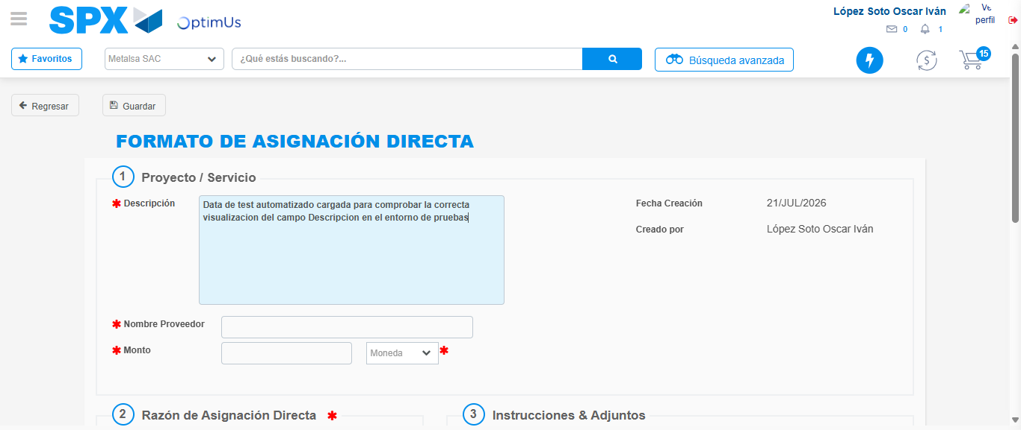Image file-name: QC_Testing-tc005_SPX_Dev5_Crear_Requisicion_Spot_Con_FAD_Tipo_Cobro_Project-1784653495662

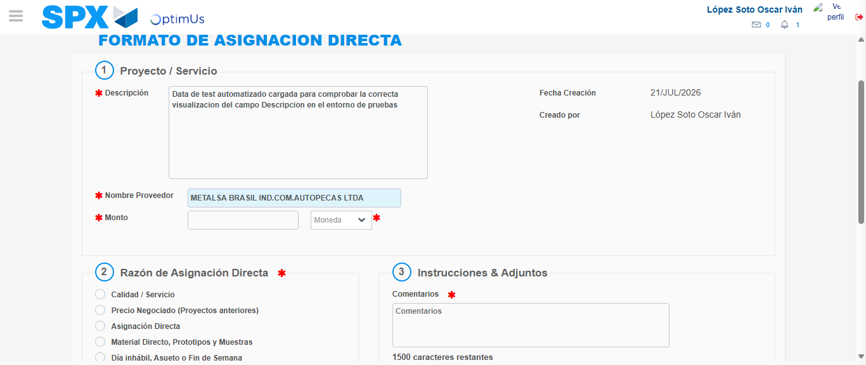Image file-name: QC_Testing-tc005_SPX_Dev5_Crear_Requisicion_Spot_Con_FAD_Tipo_Cobro_Project-1784653502506

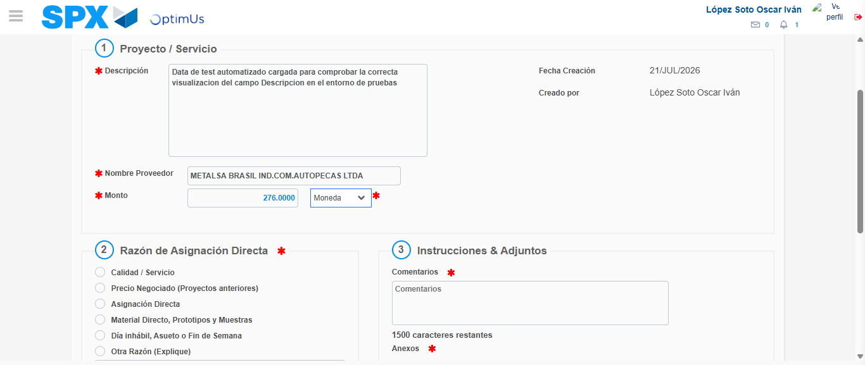Image file-name: QC_Testing-tc005_SPX_Dev5_Crear_Requisicion_Spot_Con_FAD_Tipo_Cobro_Project-1784653503029

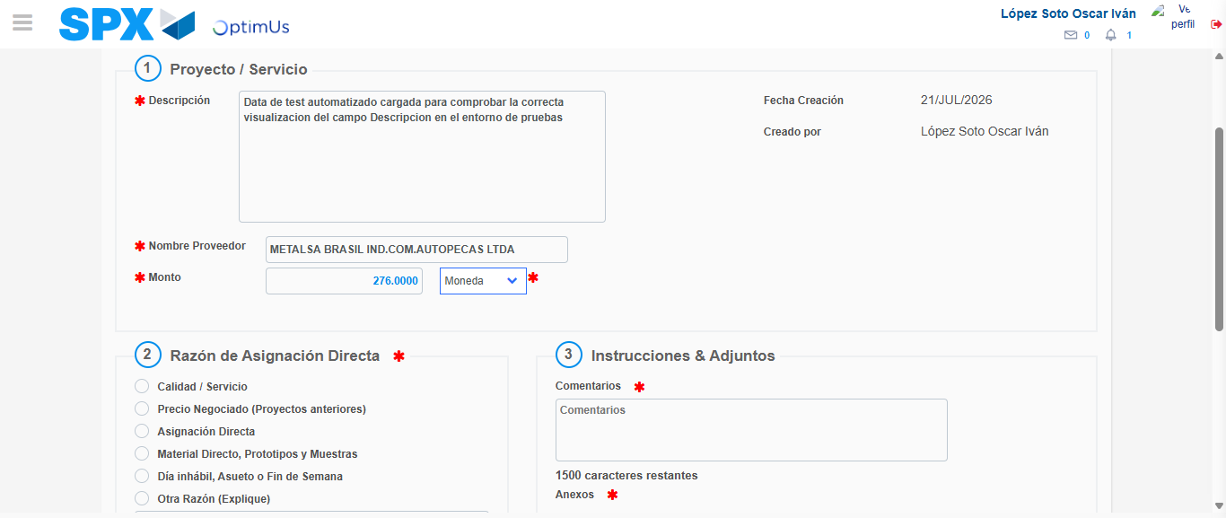Image file-name: QC_Testing-tc005_SPX_Dev5_Crear_Requisicion_Spot_Con_FAD_Tipo_Cobro_Project-1784653503263

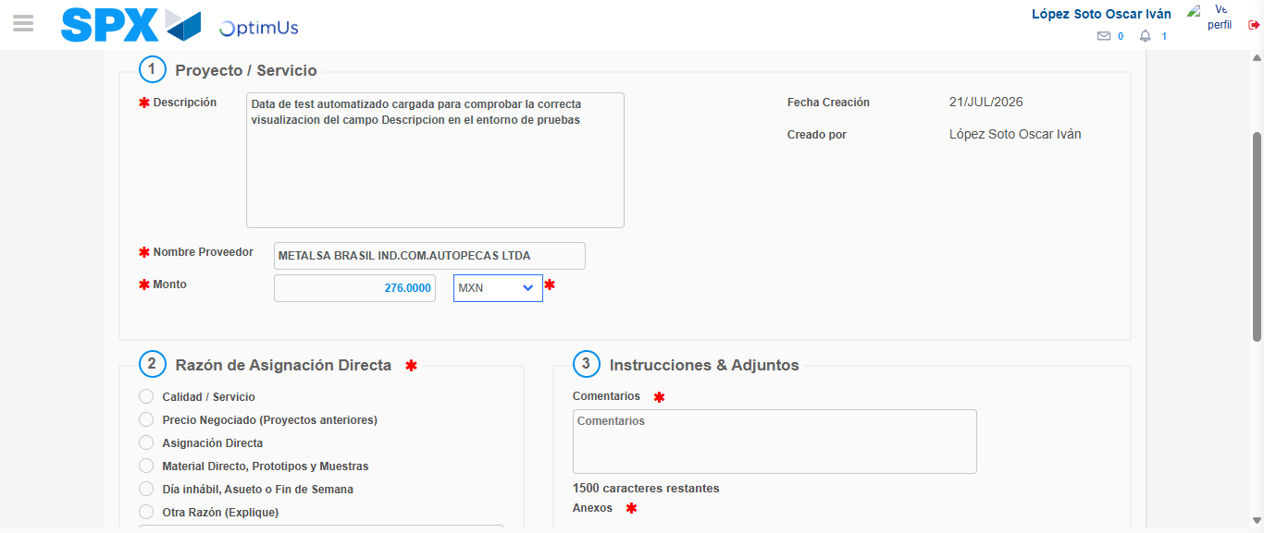Image file-name: QC_Testing-tc005_SPX_Dev5_Crear_Requisicion_Spot_Con_FAD_Tipo_Cobro_Project-1784653503731

Image file-name: QC_Testing-tc005_SPX_Dev5_Crear_Requisicion_Spot_Con_FAD_Tipo_Cobro_Project-1784653503977

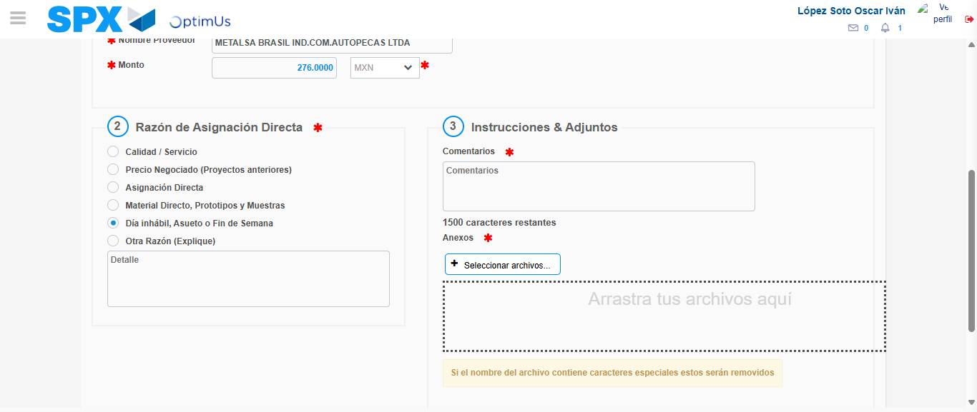Image file-name: QC_Testing-tc005_SPX_Dev5_Crear_Requisicion_Spot_Con_FAD_Tipo_Cobro_Project-1784653504924

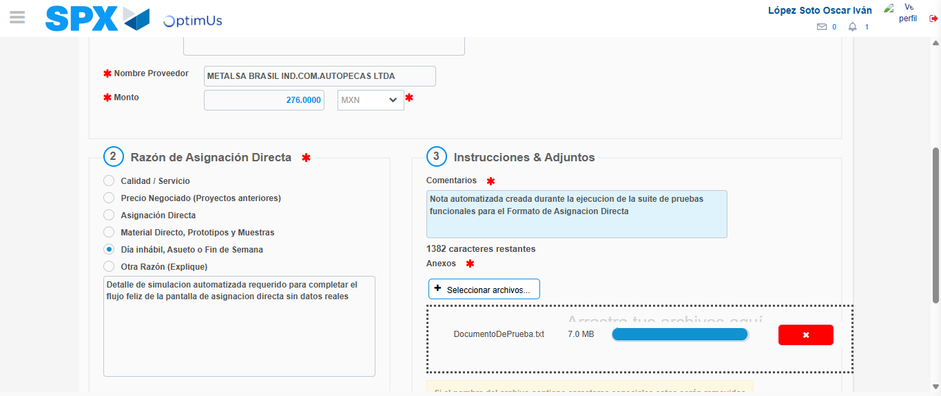Image file-name: QC_Testing-tc005_SPX_Dev5_Crear_Requisicion_Spot_Con_FAD_Tipo_Cobro_Project-1784653516293

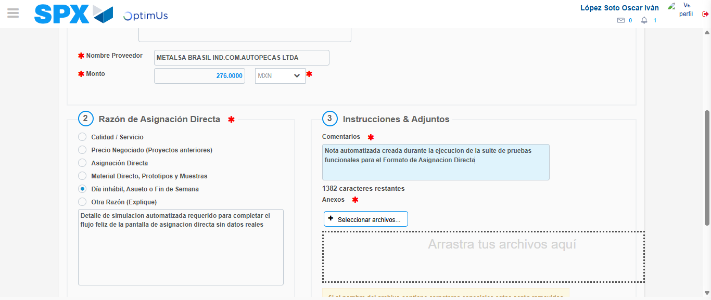Image file-name: QC_Testing-tc005_SPX_Dev5_Crear_Requisicion_Spot_Con_FAD_Tipo_Cobro_Project-1784653517726

Step 4 - Data Capture Spot Buy Requisition: Data captured correctly
Image file-name: QC_Testing-tc005_SPX_Dev5_Crear_Requisicion_Spot_Con_FAD_Tipo_Cobro_Project-1784653492362

Image file-name: QC_Testing-tc005_SPX_Dev5_Crear_Requisicion_Spot_Con_FAD_Tipo_Cobro_Project-1784653492574

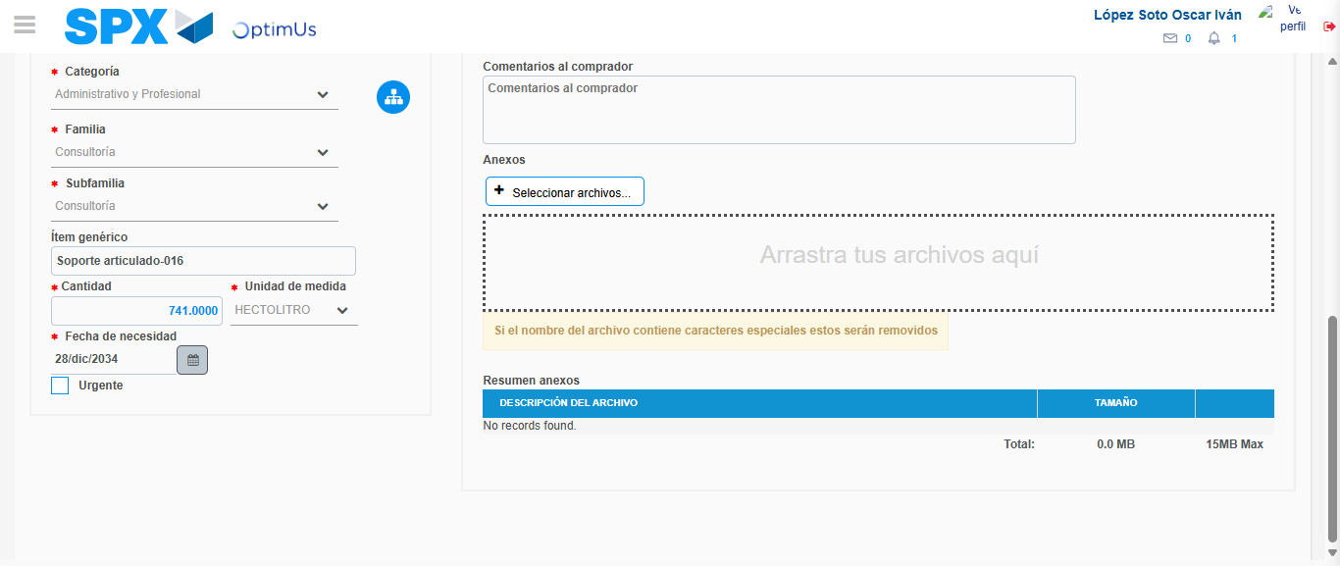Image file-name: QC_Testing-tc005_SPX_Dev5_Crear_Requisicion_Spot_Con_FAD_Tipo_Cobro_Project-1784653531403

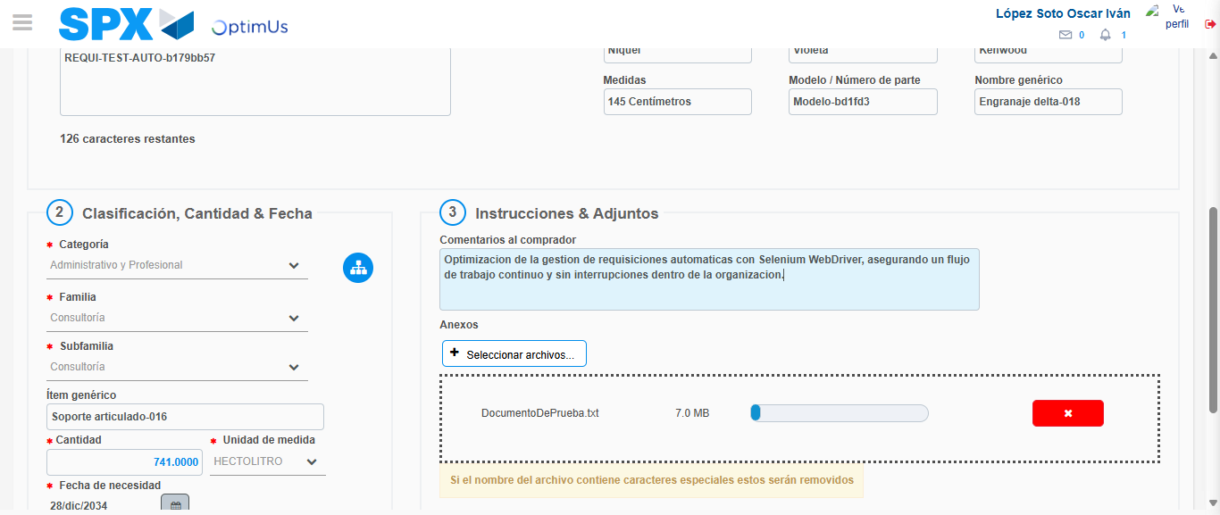Image file-name: QC_Testing-tc005_SPX_Dev5_Crear_Requisicion_Spot_Con_FAD_Tipo_Cobro_Project-1784653532431

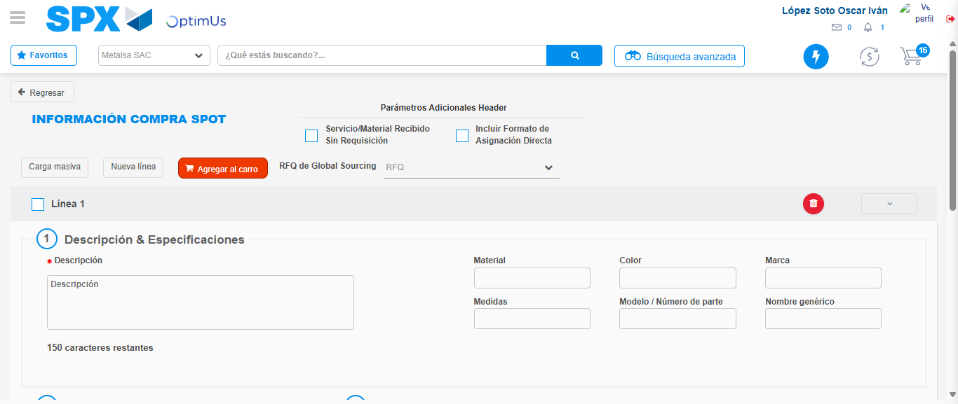Image file-name: QC_Testing-tc005_SPX_Dev5_Crear_Requisicion_Spot_Con_FAD_Tipo_Cobro_Project-1784653549984

Step 8 - Return to Main Page SPX : Return to Main Page SPX
Image file-name: QC_Testing-tc005_SPX_Dev5_Crear_Requisicion_Spot_Con_FAD_Tipo_Cobro_Project-1784653469050

Image file-name: QC_Testing-tc005_SPX_Dev5_Crear_Requisicion_Spot_Con_FAD_Tipo_Cobro_Project-1784653471849

Image file-name: QC_Testing-tc005_SPX_Dev5_Crear_Requisicion_Spot_Con_FAD_Tipo_Cobro_Project-1784653492113

Image file-name: QC_Testing-tc005_SPX_Dev5_Crear_Requisicion_Spot_Con_FAD_Tipo_Cobro_Project-1784653552258

Image file-name: QC_Testing-tc005_SPX_Dev5_Crear_Requisicion_Spot_Con_FAD_Tipo_Cobro_Project-1784653552500

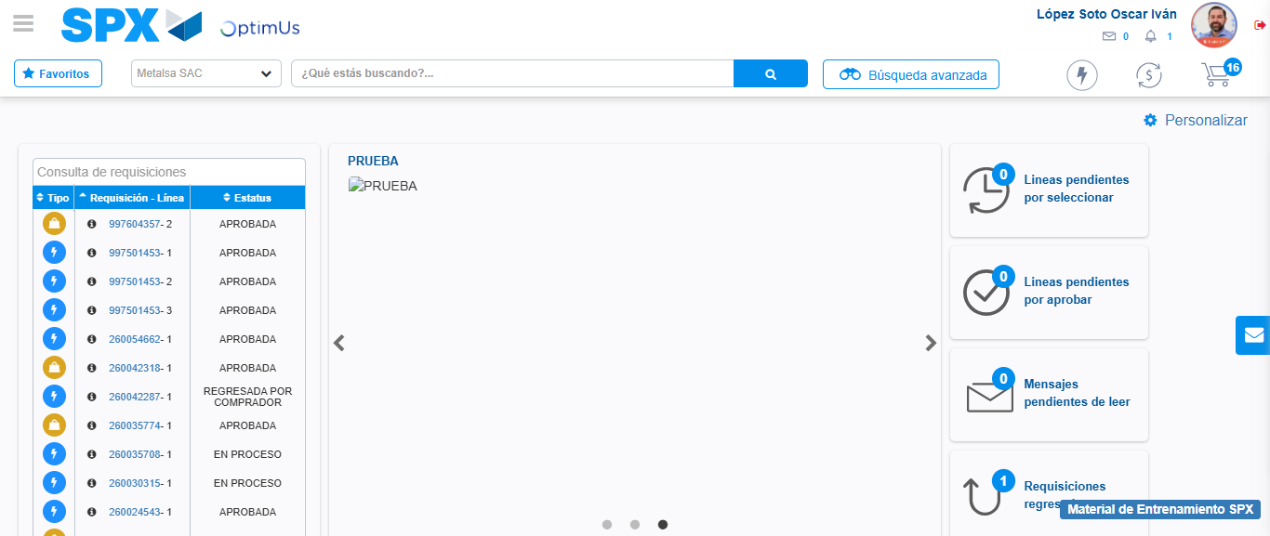Image file-name: QC_Testing-tc005_SPX_Dev5_Crear_Requisicion_Spot_Con_FAD_Tipo_Cobro_Project-1784653573775

Step 9 - Log Out : Log Out SPX
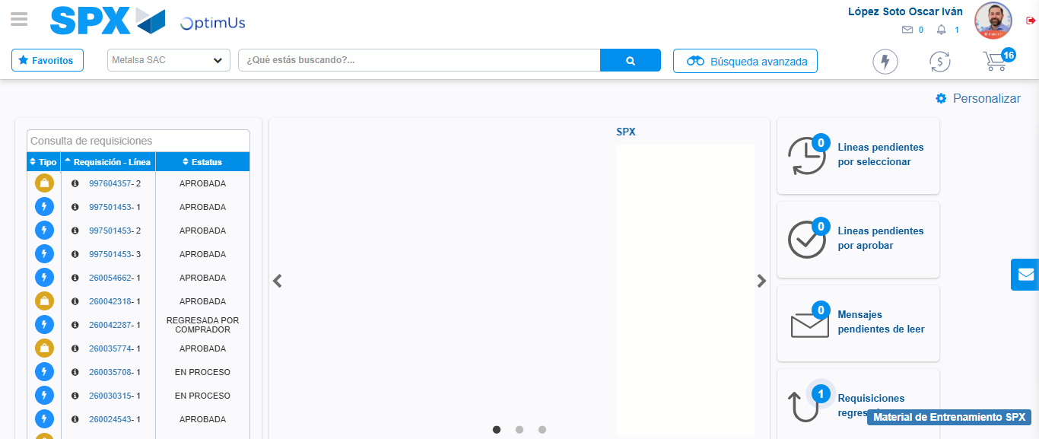Image file-name: QC_Testing-tc005_SPX_Dev5_Crear_Requisicion_Spot_Con_FAD_Tipo_Cobro_Project-1784653574050

